South West Regional Committee of the CPSA
Regional Annual General Meeting
Wednesday 28 February 2024 – 1930hrs
at The George Albert Hotel & via Zoom
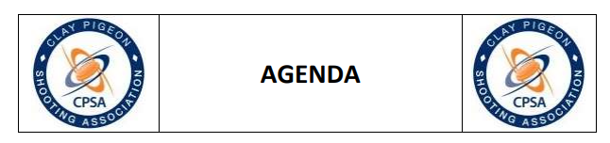

1 Welcome and Opening of Meeting by the Chairman
2 Apologies for Absence
3 Chairmans Address
4 Minutes of the Last RAGM and any Matters Arising
5 Regional Annual Reports
6 Election of Regional Officers
7 CPSA HQ News & HQ Questions from the Floor
- Cy Grieve – Membership Cards
8 Closure of the RAGM

Jane Rowland
SW Regional Secretary
Email: j4ne121@aol.com

